# CS 255 System Design Document

Student: Jose Medina   
Professor: Venckus

This template lays out all the different sections that you need to complete for Project Two. Each section has guidance to prompt your thinking. You will need to continually reference the interview transcript as you work to make sure that you are addressing your client’s needs. There is no required length for the final document. Instead the goal is to complete each section based on what your client’s needs are. Remove this note when you are finished, and replace all bracketed text with the relevant information.

## UML Diagrams

### UML Use Case Diagram

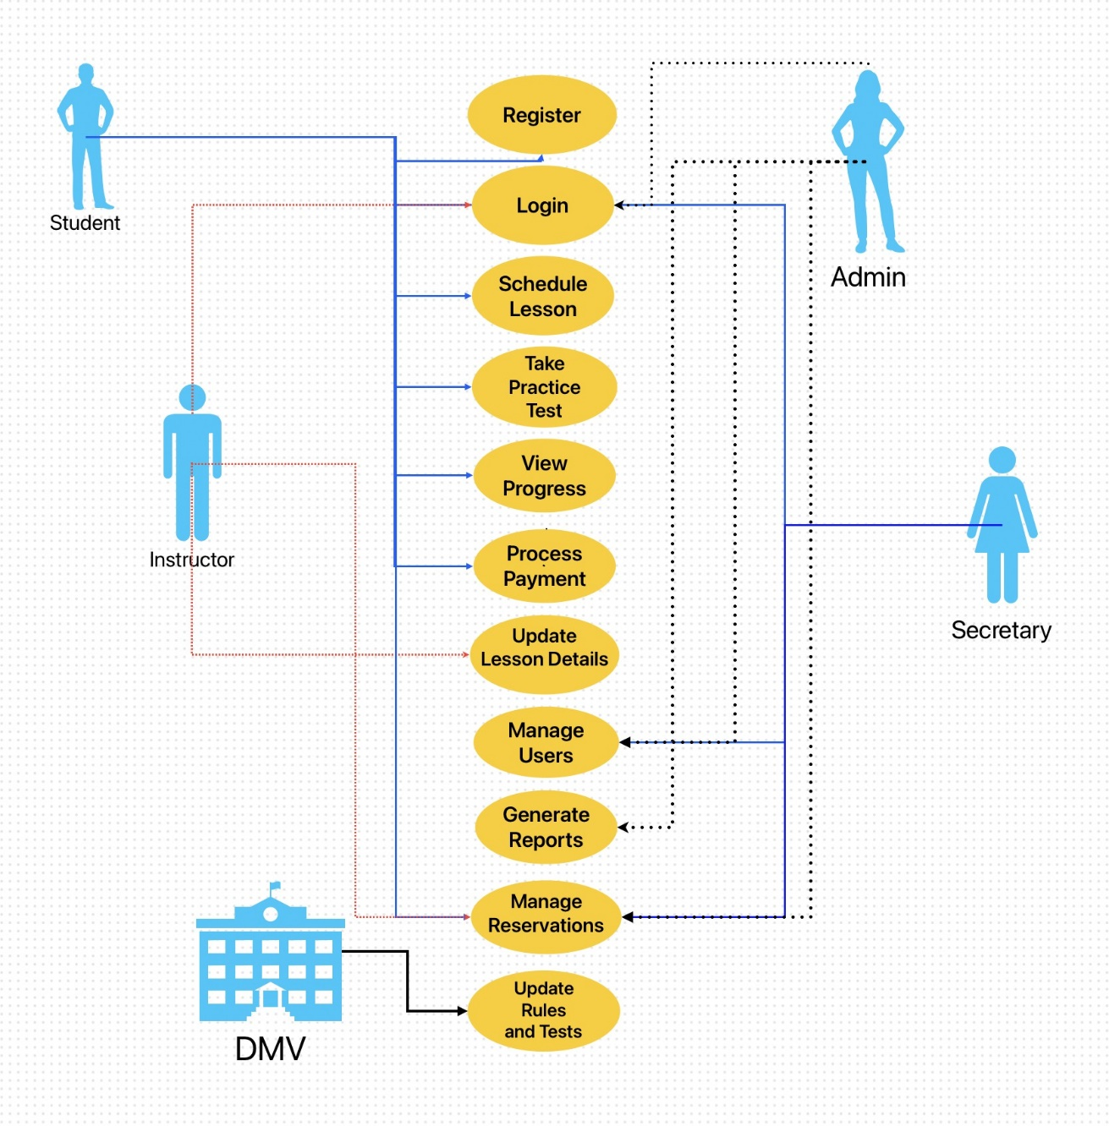

**UML Activity Diagram**

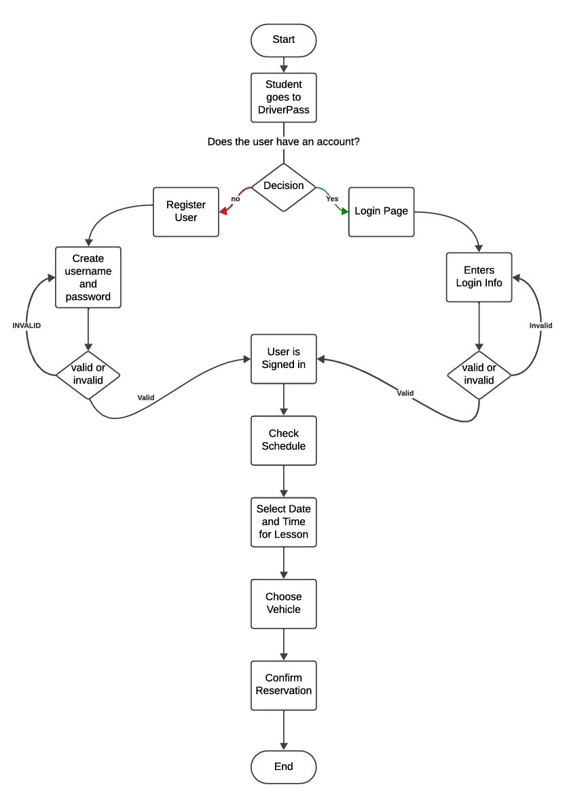

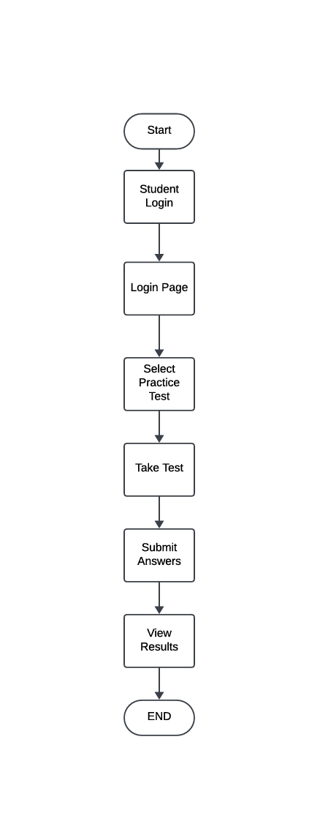

### UML Sequence Diagram

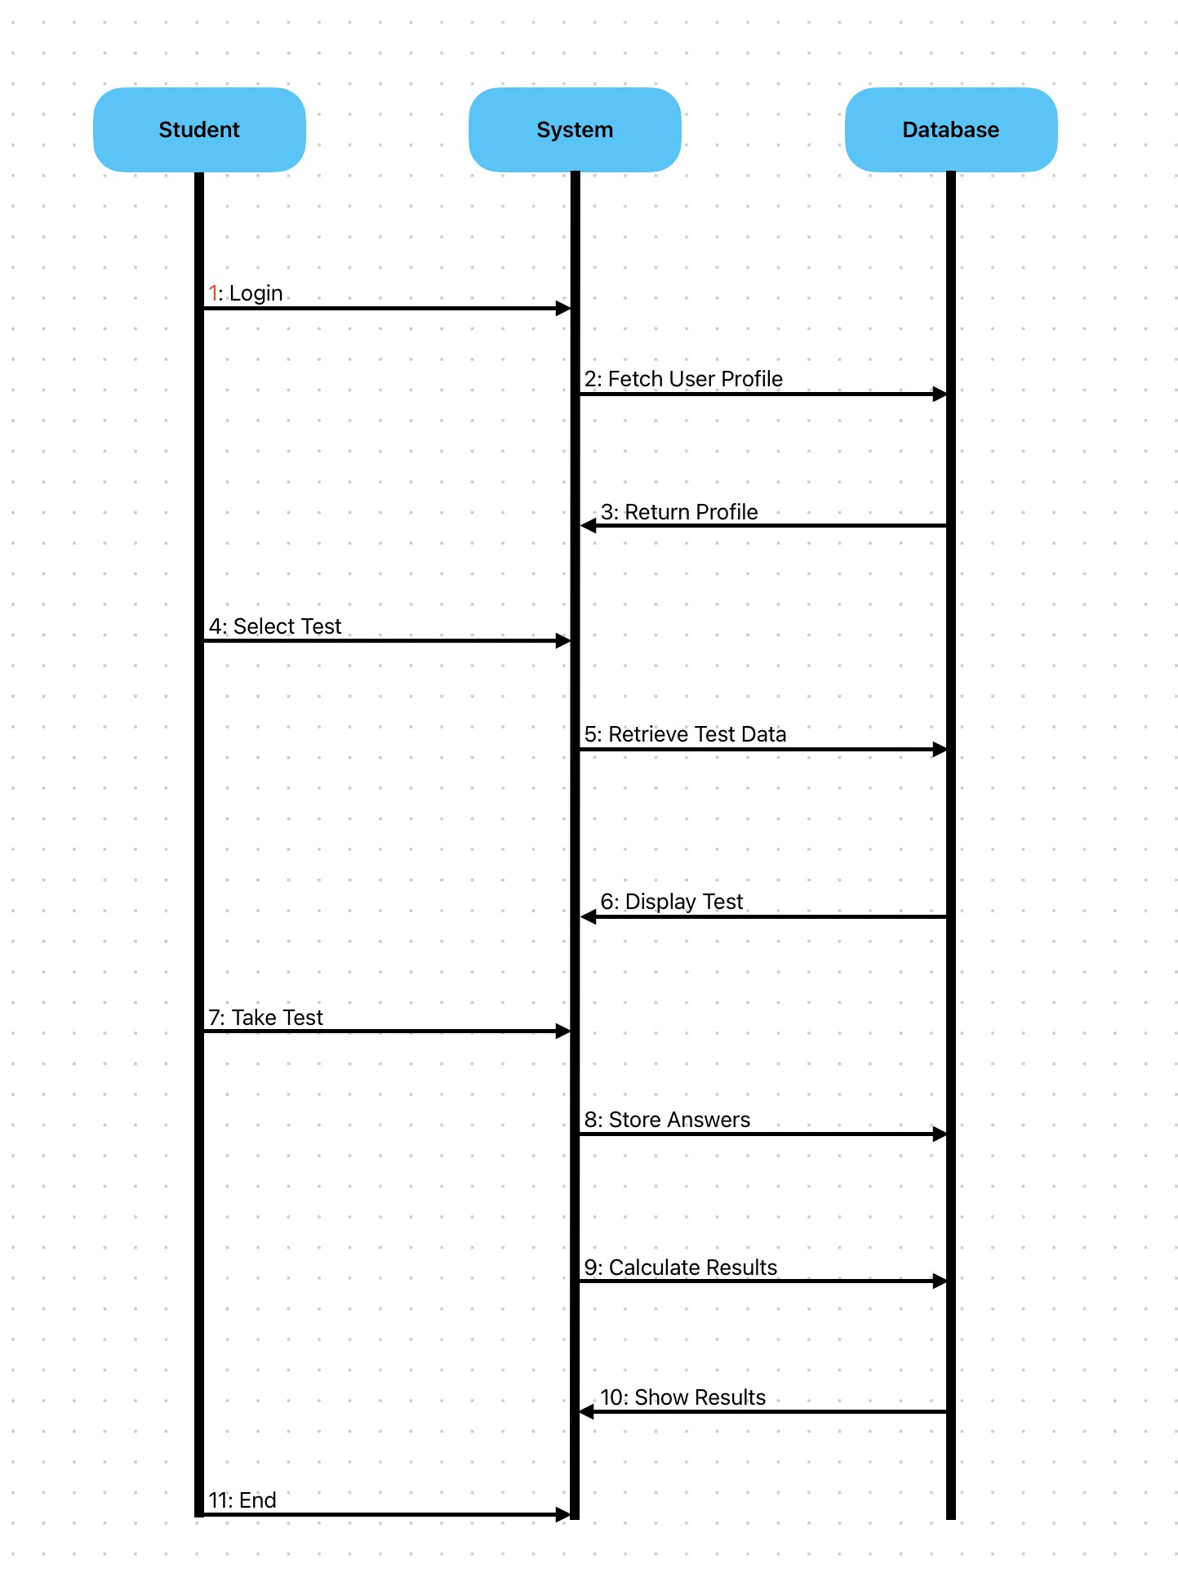

### UML Class Diagram

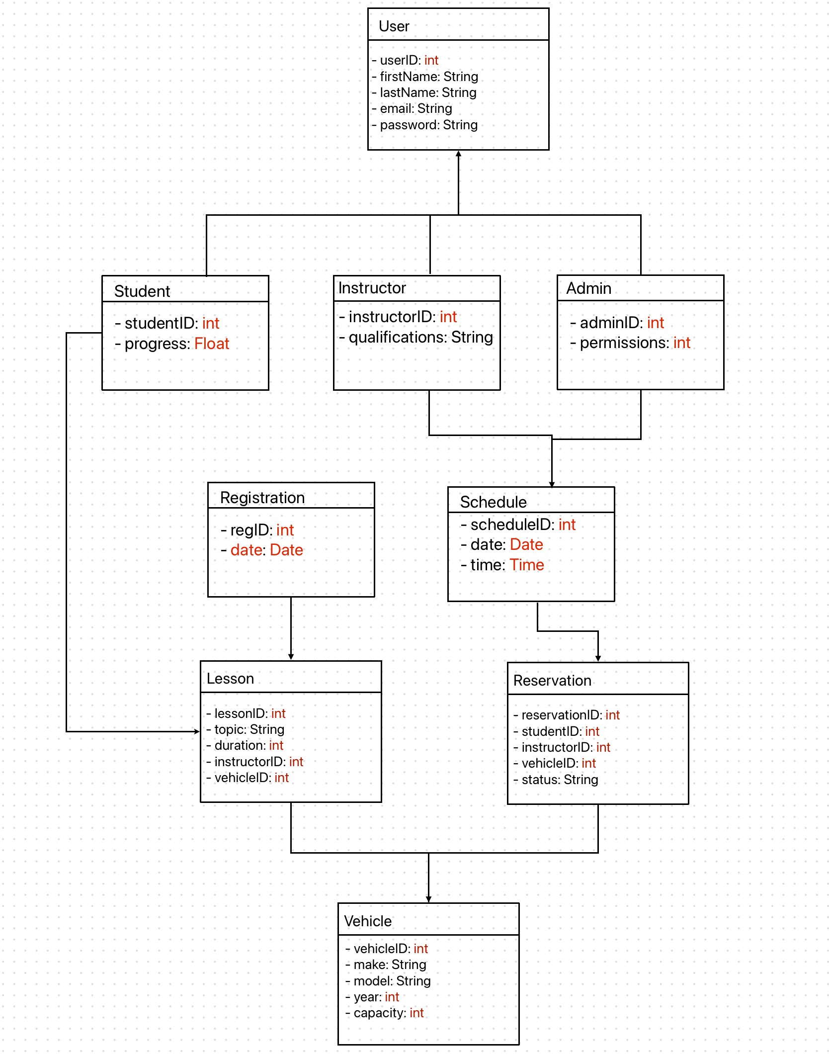

## Technical Requirements

*Hardware Requirements*

*- Server Hardware: Capable of supporting high concurrency with robust performance.*

*- Client Hardware: Accessible on standard PCs, tablets, and smartphones.*

*Software Requirements*

*- Operating Systems: Linux for servers.*

*- Web Server: Apache or Nginx.*

*- Database: MySQL or PostgreSQL.*

*- Application Server: Tomcat or Node.js.*

*Development Tools*

*- IDE: Visual Studio Code or JetBrains IntelliJ IDEA.*

*- Version Control: Git with GitHub or GitLab.*

*- UML Tool: Lucidchart for diagramming.*

*Infrastructure Requirements*

*- Cloud Hosting: AWS, Azure, or Google Cloud for scalability.*

*- CDN: To enhance content delivery speeds.*

*- Backup Solutions: Automated systems for data integrity.*

*Security Requirements*

*- HTTPS: SSL/TLS for secure communication.*

*- Firewalls: To safeguard against unauthorized access.*

*- Data Encryption: For sensitive data at rest and in transit.*

*Compliance and Standards*

*- Data Protection: Compliance with GDPR, CCPA, or similar.*

*- Accessibility: Adherence to web accessibility standards.*

*Performance and Scalability*

*- Load Balancing: Efficient distribution of requests.*

*- System Scalability: Architecture designed for easy horizontal scaling.*

*Monitoring and Maintenance*

*- Monitoring Tools: Tools like Splunk or Prometheus.*

*- Software Updates: Regular updates and patches for security.*